Robusta Coffee Beans – The Bold Essence of Strength
By The Export Express | Premium Coffee Exports from India
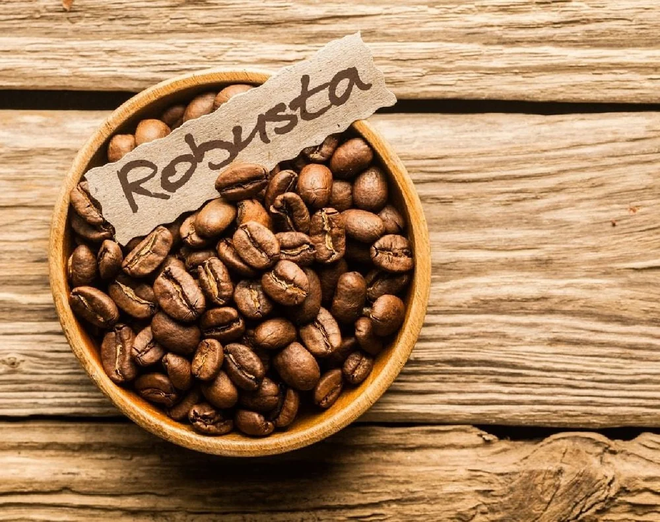

Introduction
At The Export Express, we take pride in offering the finest coffee varieties India has to offer. Among these, Robusta Coffee Beans stand out for their bold intensity, high caffeine content, and deep earthy aroma. These beans form the backbone of strong espresso blends and are a favorite among coffee producers, roasters, and cafés worldwide.
Grown in the fertile soils of southern India—particularly in Coorg, Chikkamagaluru, and Wayanad—our AAA-grade Robusta beans are handpicked, sun-dried, and processed under expert supervision to preserve their strength and purity. Whether you prefer non-roasted (green) beans for custom roasting or dark-roasted beans for ready brewing, we deliver export-grade quality with consistency and care.

🌿 What Makes Robusta Coffee Unique
Robusta (Coffea canephora) is the second most popular coffee variety in the world, prized for its strong, full-bodied flavor and twice the caffeine content of Arabica. Its natural bitterness, nutty undertones, and thick crema make it ideal for espresso lovers and those who crave a more intense brew.

Key Characteristics
- Caffeine Content: 2.2 – 2.7 % (almost double that of Arabica)
- Flavor Notes: Bold, earthy, nutty, with cocoa or woody undertones
- Texture: Full-bodied, with a dense crema when brewed as espresso
- Best Used For: Espresso blends, instant coffee, and strong filter brews
- Altitude Range: 200 – 800 m above sea level
- Shelf Life: Up to 12 months under cool, dry storage

☕ AAA Grade Robusta Coffee Beans – Green Form
Grade: AAA Variety: Robusta Color: Brown (Green Unroasted)
Shelf Life: 12 Months Packaging: Loose / Bag
Availability: In Stock

Product Overview
Our AAA-grade Robusta Green Coffee Beans are sourced from high-quality plantations in India and meticulously graded for size and density. These beans exhibit a clean brownish-green hue, a sign of optimal drying and minimal moisture retention.

Features & Benefits
- Premium Quality: Cultivated in nutrient-rich soils at moderate altitudes for balanced caffeine and natural oils.
- Perfect for Custom Roasting: Green beans allow roasters to tailor roast levels—from light to dark—suiting diverse flavor requirements.
- Health Applications: Naturally rich in caffeine and antioxidants, suitable for health-focused brews or green coffee extract formulations.
- Sustainable Source: Ethically harvested, sun-dried, and hand-graded.

🔥 AAA Grade Robusta Coffee Beans – Dark Roast
Grade: AAA Type: Roasted Roast Level: Dark Roast
Color: Deep Brown Availability: In Stock

Product Overview
Our dark-roasted Robusta beans are crafted to perfection to bring out their bold aroma and full flavor. The beans develop a thick crema and a strong aftertaste, making them ideal for espresso, filter coffee, and vending machine blends.

Flavor Profile
- Aroma: Woody & nutty with hints of cocoa
- Taste: Intense & bitter, with subtle earthy sweetness
- Texture: Rich body, thick crema, lasting finish

Ideal Applications
- Cafés and roasteries seeking espresso-grade beans
- Instant coffee manufacturers and bulk exporters
- Home baristas looking for a robust, energizing brew

🌱 Arabica–Robusta Blend (AA Grade)
Blend Ratio: 50 % Arabica | 50 % Robusta
Roast Level: Medium–Dark Availability: In Stock
The Arabica–Robusta Blend unites the smoothness of Arabica with the strength of Robusta, producing a full-bodied cup with balanced acidity and sweetness. It’s perfect for Indian filter coffee lovers and cafés serving milk-based beverages such as cappuccinos and lattes.

Flavor & Aroma
- Notes: Chocolate, spice, dried fruit, and subtle nuttiness
- Mouthfeel: Creamy, rich body with balanced acidity
- Usage: Automatic machines, filter brews, and espresso blends

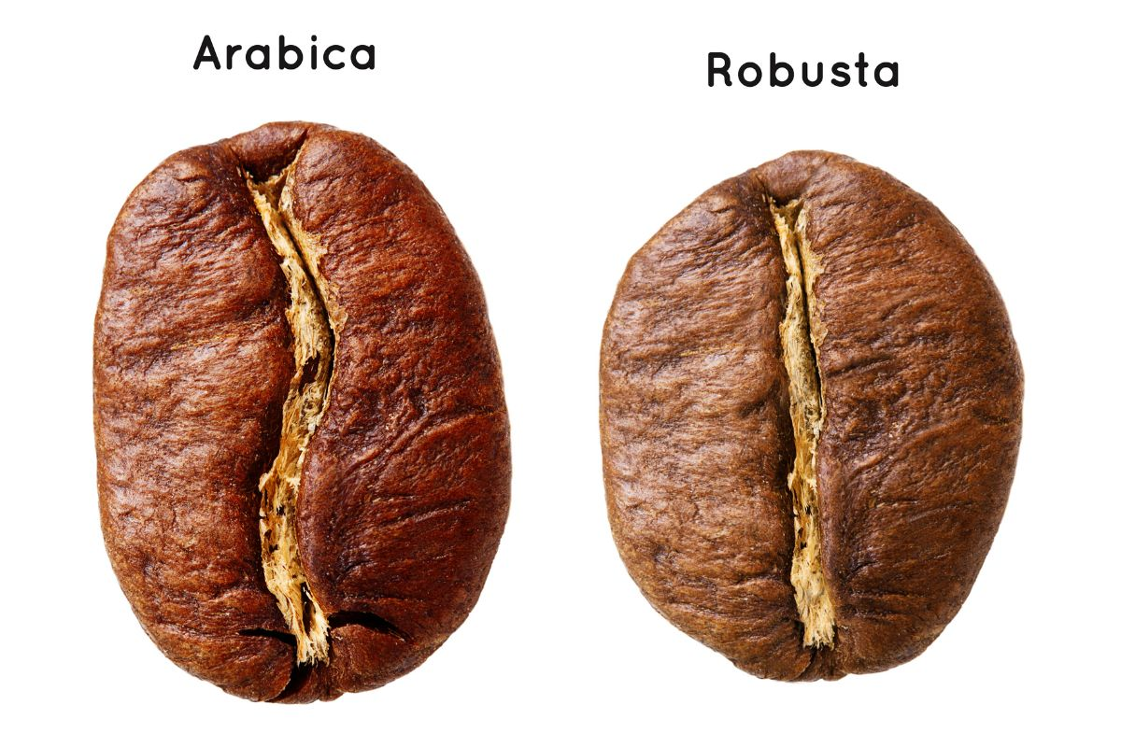

☕ Arabica vs Robusta – The Key Differences
Feature | Arabica (Coffea arabica) | Robusta (Coffea canephora)
Flavor Profile | Smooth, mild, fruity & sweet | Bold, bitter, earthy, nutty
Caffeine Content | 1 – 1.5 % | 2 – 2.7 %
Acidity | Higher, giving brighter taste | Lower, producing strong body
Shape of Bean | Oval with curved center cut | Round & straight center cut
Crema (Espresso) | Light, delicate layer | Thick & dense layer
Altitude | 1,000 – 2,000 m | 200 – 800 m
Aroma | Floral & fruity | Woody & nutty
Price Range | Higher due to lower yield | More economical
Best For | Specialty & single-origin coffees | Espresso, instant, and blends
Conclusion of Comparison:
While Arabica appeals to those who prefer subtle, aromatic coffee, Robusta caters to lovers of strong, full-bodied brews. At The Export Express, we cater to both—ensuring premium quality across all grades and forms.

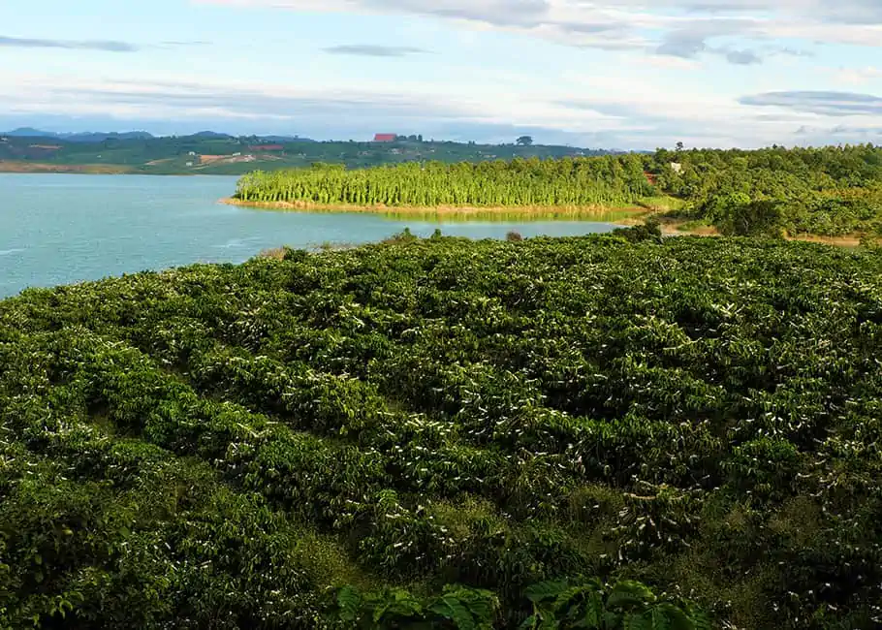

🌍 The Journey from Plantation to Cup

Step 1: Harvesting
Each Robusta cherry is handpicked once fully ripe, ensuring that only the finest beans make it to processing.

Step 2: Drying & Processing
Beans are sun-dried under controlled conditions to reduce moisture and enhance shelf life. For our green coffee line, we maintain natural oils and structure for export stability.

Step 3: Grading & Sorting
The beans are graded (AAA / AA / A) based on size, color uniformity, and density—ensuring consistent roasting performance.

Step 4: Roasting Excellence
Using temperature-controlled roasters, the beans are brought to precise roast levels—light, medium, or dark—unlocking complex flavors.

Step 5: Packaging & Export
Beans are packed in moisture-proof gunny / paper bags and stored in cool, dry conditions. We export globally, meeting stringent quality and food-safety standards.

⚙️ Technical Specifications
Parameter | Specification
Grade | AAA
Variety | Robusta
Moisture Content | ≤ 12 %
Color | Brown / Green
Roast Levels Available | Non-Roasted (Green) / Dark Roast
Aroma Profile | Woody & nutty with chocolatey undertones
Packaging Options | Loose / Bag / Export Drum
Shelf Life | 12 Months
Storage Instructions | Cool, dry, airtight container
Origin | Southern India
Availability | In Stock – Bulk & Private Label

🌟 Why Choose The Export Express for Robusta Coffee Beans
- Premium AAA Grade: Hand-sorted beans for uniform size & flavor consistency.
- Custom Roasting & Blending: Choose between green, medium, or dark roast.
- Flexible Packaging: Gunny bags, pouches, or custom-labeled export packs.
- Sustainable Farming: Sourced from ethical farms supporting local growers.
- Global Export Network: Proven supply to cafés, roasters, and wholesalers worldwide.
- Quality Certifications: FSSAI, ISO, and lab-tested for purity and safety.
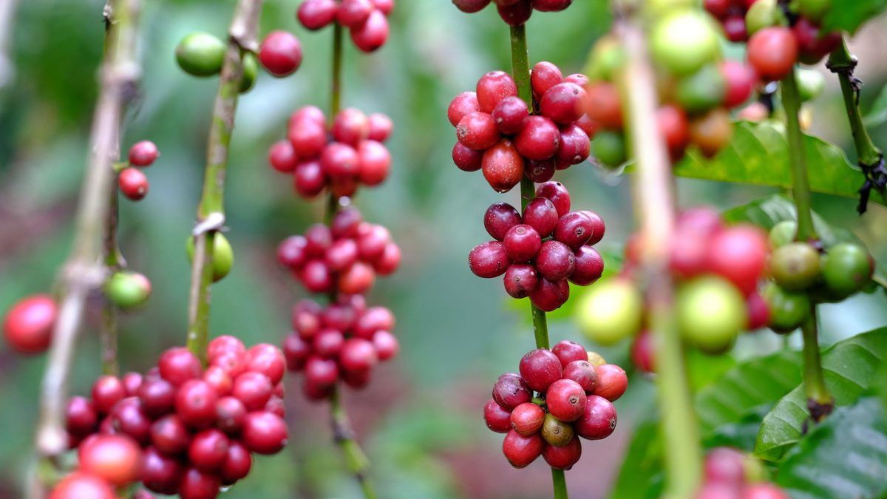

🌿 The Flavor Experience
A sip of Robusta reveals a deep, resonant strength—the kind that lingers on the palate. Its natural bitterness pairs beautifully with milk or cream, and when blended with Arabica, it creates a cup that balances intensity with aroma.
For espresso enthusiasts, Robusta ensures a dense crema and lingering finish. For filter coffee drinkers, it delivers that quintessential Indian kick—energizing, aromatic, and satisfying.

📦 Available Products
- Robusta AAA Green Coffee Beans – For roasters & health brews
- Robusta AAA Dark Roast Beans – For espresso & filter coffee
- Arabica–Robusta AA Blend – Balanced cup for cafés & vending machines
All variants are available in stock and customizable for bulk or private-label export orders.

🏁 Conclusion
The legacy of Indian coffee is rich and robust—and at The Export Express, we bring that legacy to life through every bean we export. Our Robusta Coffee Beans, graded AAA and processed under global quality standards, embody strength, purity, and authenticity.
From the unroasted green beans favored by roasters to the dark-roasted beans preferred by espresso bars, our products deliver the true taste of India—bold, aromatic, and unforgettable.
Partner with The Export Express and experience coffee that doesn’t just wake you up—it defines excellence in every brew.

Keywords: Robusta Coffee Beans Export India | AAA Robusta Beans | Arabica vs Robusta | Indian Coffee Exporter | Green Coffee Beans Supplier India

